Environmental Policy
of
RDFencing Ltd.
Reliable, Durable, Fencing, Landscaping &. Construction

Lochview
Wester Essendy
Blairgowrie
Perthshire
PH10 6RD


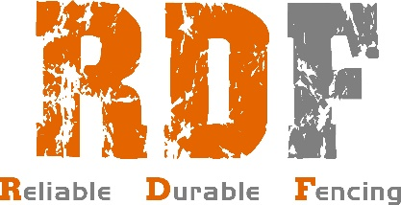

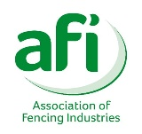
Mobile: 07720761221 Email: richieduncan@rdfencing.uk.com
RDFencing Ltd. is committed at all levels and in all functions of the organisation, to using the best practicable means to minimise the effect the undertaking has upon the environment. We aim for continual improvement. It is our policy to plan, implement and monitor our activities to ensure compliance with the following:
- Any risk of pollution to land or water courses arising from our activities, products and/or services will be identified and appropriate means of elimination or control taken to meet or exceed the requirements of environmental legislation.
- We will insure wherever practical, measures are implemented to protect and preserve natural habitats, flora and fauna.
- We will use only Bio Oil in chainsaws and machinery.
- Existing wildlife habitats will be respected and any new development will be subject to an environmental assessment.
- Air emissions, malodours, noise, from processes or traffic, and other aspects of RDFencing Ltd. operations that may impact upon the local community, will be controlled to the lowest practicable level.
- Vehicles will be operated and maintained to operate at maximum efficiency and to minimise the environmental impact
- As a contractor , we are aware of CDM 2015 document and we work to the PC STROKE WORK requirements.
- Preference will be given to energy, materials and other resources having the lease adverse impact on the environment, and unnecessary or excessive use avoided.
- Waste products will be minimised and recycled where reasonably practicable. Where it is not, they will be disposed of in accordance with statutory requirements, via licensed contractors or through other responsible and recorded means.
- We will seek assurance from third parties that their products and/or services can be used, handled, stored and disposed of in a manner which safeguards the environment and the health and safety of all those who may be affected.
- All employees and persons working on our behalf, including contractors and sub-contractors, will be made aware of their responsibilities and agree to comply with our Company policy and standards.
- Concerns and complaints from individuals within or outside the company, including members of the public, will be dealt with promptly and with transparency.
- Our Environmental Policy will be reviewed annually to ensure it remains applicable to the context of the Organisation.
Signed: Richie Duncan Date: 08/01/26
Name: Richie Duncan Position: MD

